# Practical 2:- UDP communication

**Q. Write a client server based program using UDP to find the factorial of the entered number.**

* **udpClientFactorial.java**

import java.io.*;

import java.net.*;

public class udpClientFactorial

{

    public static void main(String args[])

    {

        try

        {

            DatagramSocket ds = new DatagramSocket(1000);

            BufferedReader br = new BufferedReader(new InputStreamReader(System.in));

            System.out.println("Enter a number : ");

            String num = br.readLine();

            byte b[] = new byte[1024];

            b=num.getBytes();

            DatagramPacket dp = new DatagramPacket(b,b.length,InetAddress.getLocalHost(),2000);

            ds.send(dp);

            byte b1[] = new byte[1024];

            DatagramPacket dp1 = new DatagramPacket(b1,b1.length);

            ds.receive(dp1);

            String str = new String(dp1.getData(),0,dp1.getLength());

            System.out.println(str);

        }

        catch(Exception e)

        {

            e.printStackTrace();

        }

    }

}

**Output:-**

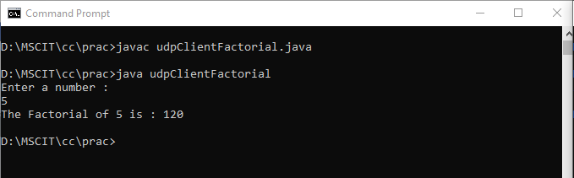

* **udpServerFactorial.java**

import java.io.*;

import java.net.*;

public class udpServerFactorial

{

    public static void main(String args[])

    {

        try

        {

            DatagramSocket ds = new DatagramSocket(2000);

            byte b[] = new byte[1024];

            DatagramPacket dp = new DatagramPacket(b,b.length);

            ds.receive(dp);

            String str = new String(dp.getData(),0,dp.getLength());

            System.out.println(str);

            int a= Integer.parseInt(str);

            int f = 1, i;

            String s= new String();

            for(i=1;i<=a;i++)

            {

            f=f*i;

            }

            s=Integer.toString(f);

            String str1 = "The Factorial of " + str + " is : " + f;

            byte b1[] = new byte[1024];

            b1 = str1.getBytes();

            DatagramPacket dp1 = new DatagramPacket(b1,b1.length,InetAddress.getLocalHost(),1000);

            ds.send(dp1);

        }

        catch(Exception e)

        {

            e.printStackTrace();

        }

    }

}

* **Output:-**

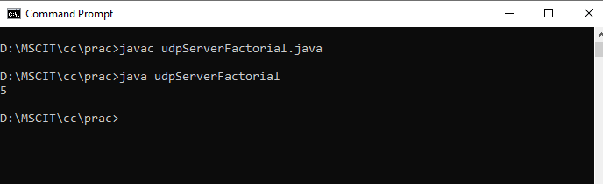

* **Final output of UDP:**

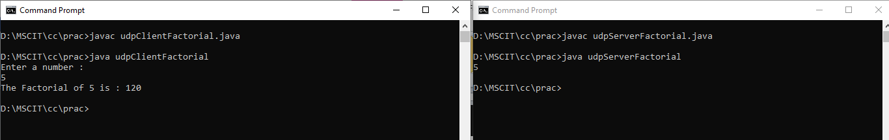

* **File Structure**

